# Overview

This document contains the necessary information to build the Raindrop Switch, a small affordable assistive switch.

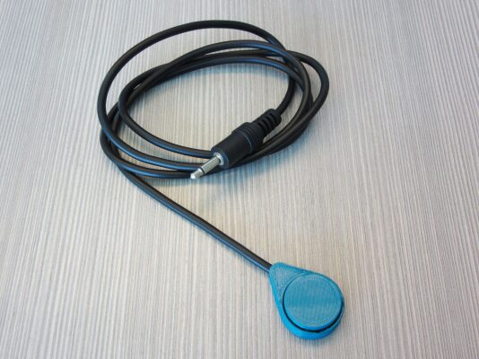

Contents

Overview 1

Maker Checklist 3

Maker To Do List 3

Items to Give to User 3

Tool List 4

Tools / Equipment 4

Supplies 4

Personal Protective Equipment (PPE) 4

Customization Guide 5

3D Printing Guide 5

3D Printing Summary 5

3D Printing Settings 5

Post-Processing 5

Examples of Quality Prints 6

Maker Component List 7

Required Tools and Supplies 7

Required Personal Protective Equipment (PPE) 7

Raindrop Switch Assembly Steps 8

Testing 16

Troubleshooting 16

# Maker Checklist

This list provides an overview of the steps required to build and deliver the Raindrop Switch

## Maker To Do List

* Read through the Maker Guide to become familiar with required components, tools, supplies, safety gear, and overall assembly steps.
* Talk to the User about customization options
  + Switch base and cap can be printed in different colours
  + How they would like to receive the “User Guide” (physical or soft copy)
* Order hardware components
* Gather tools, supplies, and safety equipment.
* Assemble the device
* Test the Raindrop switch
* Print “User Guide” (if the User would like a physical copy)

## Items to Give to User

* Raindrop switch
* “User Guide”

# Tool List

## Tools / Equipment

|  |  |  |  |
| --- | --- | --- | --- |
| Tool ID | Description | Required / Recommended | Notes |
| T01 | Flush Cutters | Required | Trimming unused parts of the button |
| T02 | Soldering Iron | Required | Connecting the button and the cable |
| T03 | Hot Glue Gun | Required | Securing the switch components to the base |
| T04 | Pliers | Recommended | Straightening the leads to the button |
| T05 | Wire Strippers | Required | Cutting the cable, and stripping the component wires |
| T06 | Soldering Jig | Optional | Holds the button and cable in place for soldering |

## Supplies

|  |  |  |  |  |
| --- | --- | --- | --- | --- |
| Supplies ID | Description | Quantity | | Notes |
| S01 | Solder | A small amount | Soldering the mono cable to the tactile switch. | |
| S02 | Hot glue | A small amount | Holds the tactile switch in place and provides strain relief on the cable. | |

## Personal Protective Equipment (PPE)

|  |  |  |
| --- | --- | --- |
| PPE ID | Description | Notes |
| P01 | Safety Glasses | Protecting your eyes |

# Customization Guide

The device can be printed in the user’s desired colour.

The base and cap can be printed in the same colour or printed in different colours.

# 3D Printing Guide

The device was originally printed on an Ender 3 using Cura.

Default slicer profile was used for all prints.

## 3D Printing Summary

|  |  |
| --- | --- |
| **Metrics** | **Single Unit** |
| Total Print Time (min) | 56min |
| Total Number of Components | 3 |
| Typical Total Mass (g) | 6g |
| Typical Number of Print Setups | 1 |

## 3D Printing Settings

|  |  |  |  |  |  |  |  |
| --- | --- | --- | --- | --- | --- | --- | --- |
| **Print File Name** | **Qty** | **Total Print Time (hr:min)** | **Mass (g)** | **Infill (%)** | **Support(Y/N)** | **Layer Height/ Nozzle Diameter(mm)** | **Notes** |
| Raindrop_Base_v1.2.stl | 1 | 0:12 | 1 | 20 | N | 0.2/0.4 |  |
| Raindrop_Cap_v1.0.stl | 1 | 0:08 | 1 | 20 | N | 0.2/0.4 |  |
| Switch_Jig_12mm_v1.0.stl | 1 | 0:36 | 4 | 20 | N | 0.2/0.4 |  |

## Post-Processing

Inspect the 3D printed parts for any printing defects, sharp edges, or burrs. Sharp edges and burrs can be removed with sanding or deburring tools.

## Examples of Quality Prints

Compare your 3D prints to the images here. If there are significant differences, you may need to reprint the part.

|  |  |  |
| --- | --- | --- |
| Raindrop Switch | | |
| Raindrop_Base_v1.2.stl | Raindrop_Cap_v1.0.stl | Switch_Jig_12mm_v1.0.stl |
|  |  |  |

# Maker Component List

|  |  |  |  |  |  |  |  |  |  |  |
| --- | --- | --- | --- | --- | --- | --- | --- | --- | --- | --- |
| Raindrop Switch | | | | | | | | | | |
| A01 | Tactile Button | | | QTY: 1 | A02 | Mono Cable | QTY: 1 | A03 | Raindrop Base | QTY: 1 |
|  | | | | |  | | |  | | |
| A04 | | Raindrop Cap | QTY: 1 | |
|  | | | | |

### Required Tools and Supplies

* Flush Cutters
* Soldering Iron
* Hot Glue Gun
* Pliers
* Wire Strippers
* Switch_Jig_12mm (optional)

### Required Personal Protective Equipment (PPE)

* Safety Glasses

### Raindrop Switch Assembly Steps

#### Step 01: Trim the button leads

Cut off the two leads flush on one side of the button (A01) using the flush cutters (T01).

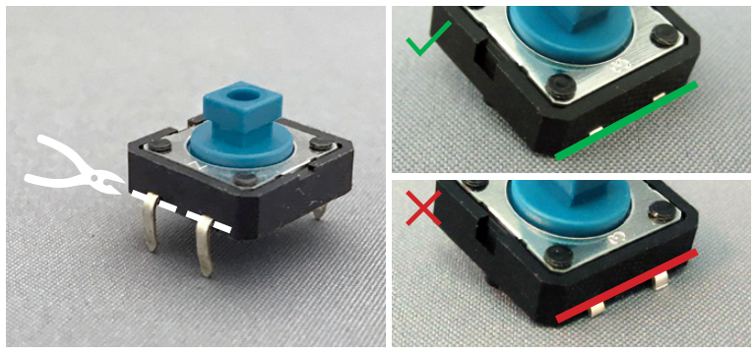

#### Step 02: Bend the remaining leads

Take the two remaining leads on the button, and bend them 90 degrees using pliers (T04).

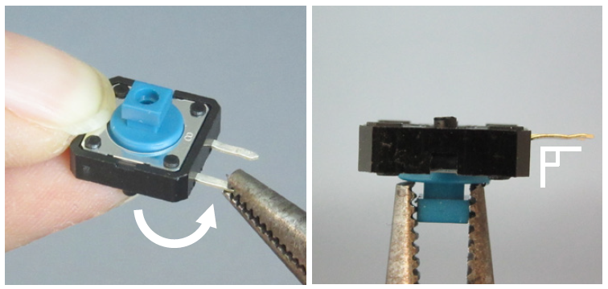

#### Step 03: Trim the mounting lugs

Cut off the two plastic mounting lugs completely flush using flush cutters (T01).

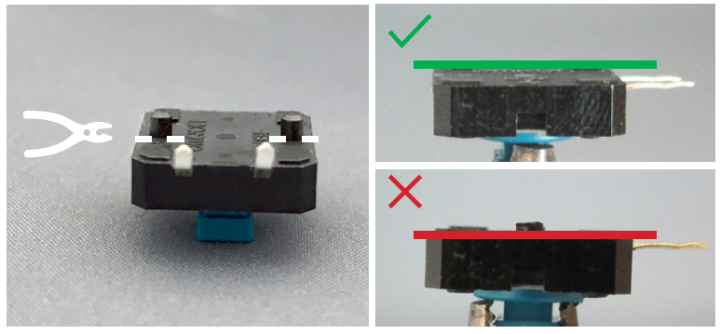

#### Step 04: Cut the mono cable in half

Using flush cutters (T01), cut the mono cable (A02) in half.

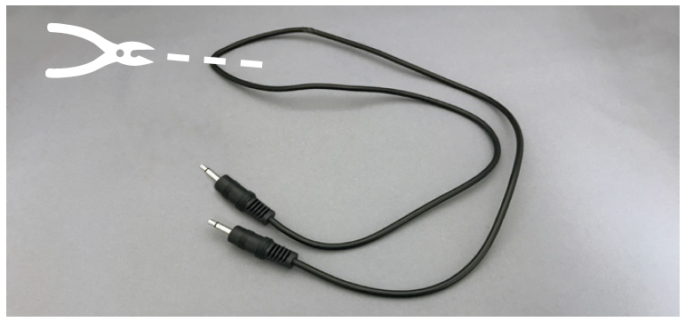

#### Step 05: Thread the cable onto the base

Thread the cut end of one half of the mono cable through the hole in the base of the switch (A03).

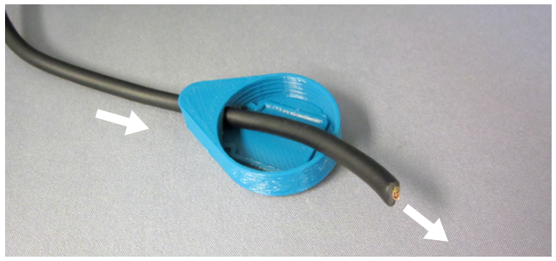

#### Step 06: Strip the end of the cable

Using wire strippers (T05), strip the last two centimeters of the mono cable. Twist the loose copper into a solid strand.

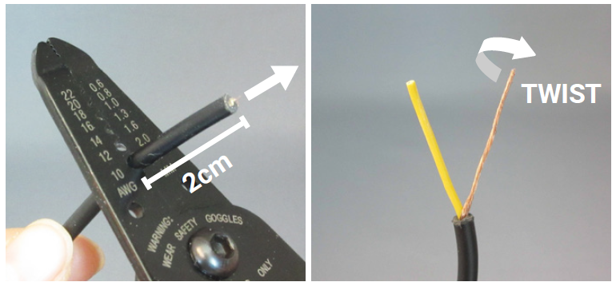

#### Step 07: Strip the interior cable

Strip the insulation off the remaining cable, and twist the loose wires into a solid strand.

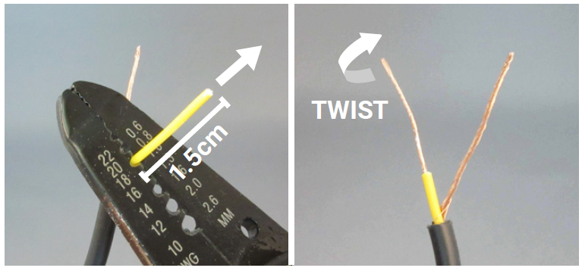

#### Step 08: Wrap the wires around the switch leads

Hold the cable behind the switch and wrap the wire around the switch leads with a plier.

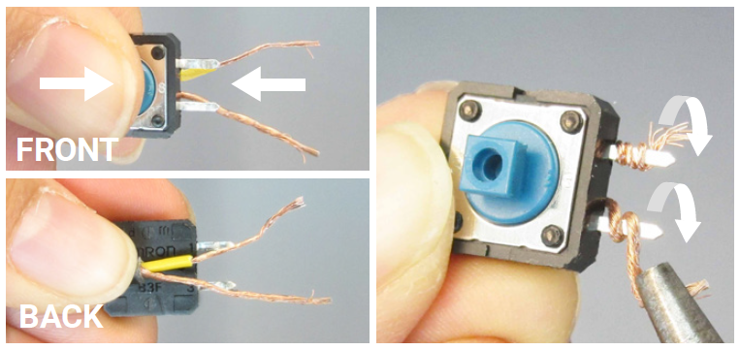

#### Step 09: Bend the wire

Hold the switch in place and cable the wire in between the two switch leads.

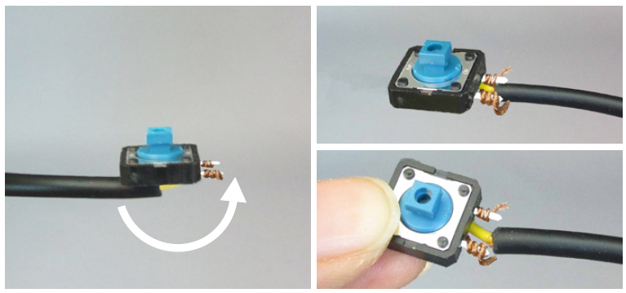

#### Step 10: Solder the cable to the button

Solder the cable to the leads on the switch using a soldering iron (T02). The soldering jig (T06) can be used to hold the assembly together while soldering. **IMPORTANT: After soldering the two leads, test the switch by following the instructions in the testing section.**

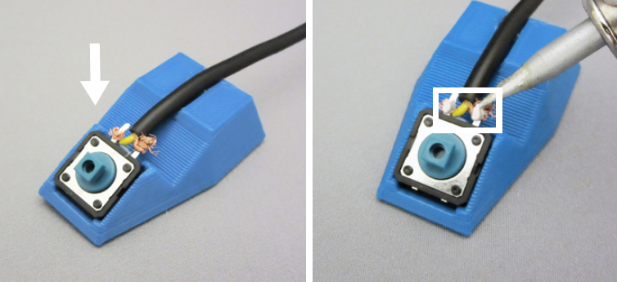

#### Step 11: Move the case closer to the switch

Pull the cable through the base so that the switch assembly is much closer to the base.

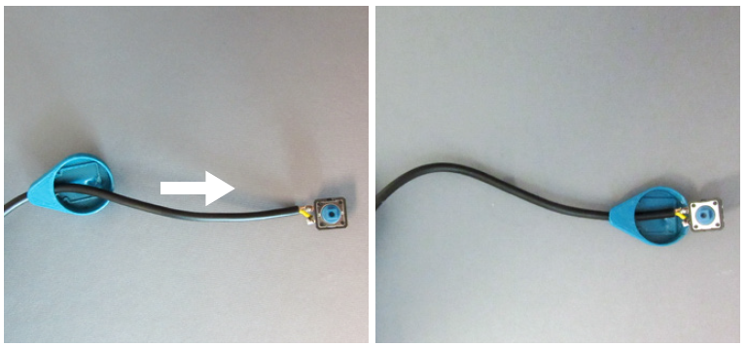

#### Step 12: Add hot glue to the base

Add a small drop of hot glue (T03) to the base. Do not add too much, a pin head sized blob is enough.

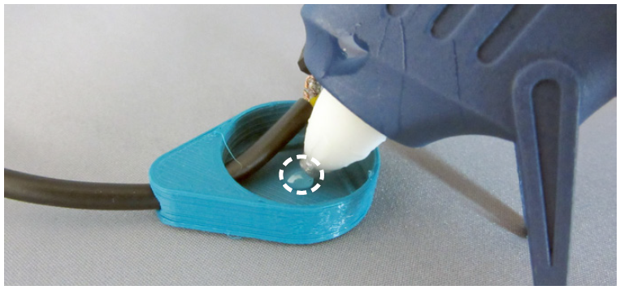

#### Step 13: Press the switch into the base

Press the switch into the recess in the base with the hot glue drop in it. Make sure the switch is sitting level in the case.

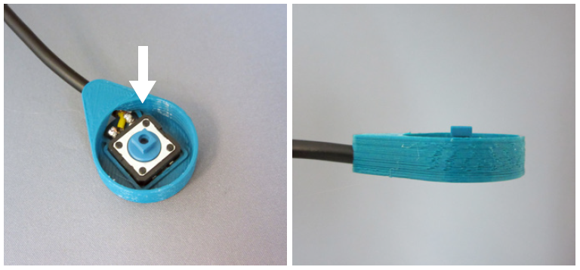

#### Step 14: Add hot glue onto the cap

Add a small drop of hot glue in the square recess in the cap. Do not add too much.

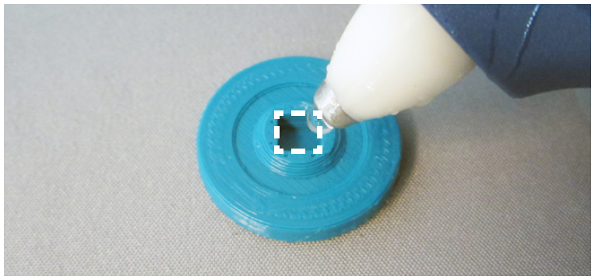

#### Step 15: Press the assembly onto the cap

Press the knob on the switch into the hot glue on the cap. To prevent hot glue in the cap from oozing downwards, press the case assembly onto the cap.

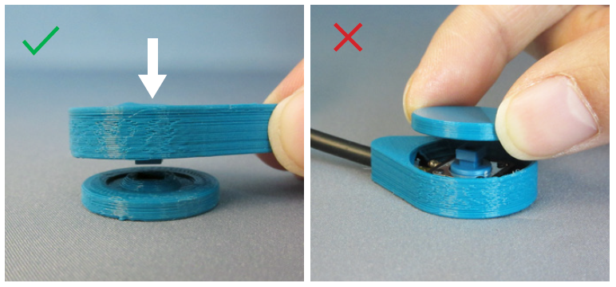

#### Step 16: Fill the hollow on the switch bottom

Fill the hollow on the bottom of the switch with hot glue to secure the cable. Do not overfill the hollow of the switch will not sit flat.

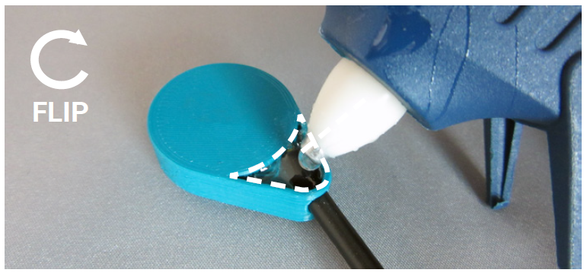

# Testing

Using a switch tester, test that the switch is working. The light should turn on when the switch is pressed, and turn off when the switch is released.

# Troubleshooting

If the switch is not working properly, check the solder joints between the button and cable to make sure the cable has not come loose from the cable.

If the lead on the button has broken off, replace it with a new button.

If the wire has broken off the cable, cut the cable back a centimeter and repeat steps 6-10 to reattach the cable.